Bangladesh University Of Business & Technology



LAB REPORT

Course Code : CSE-207

Course Title : Database Systems

Experiment Name : Create database & table, Insert data in table and solving the questions from the tables using xampp software.

Experiment No. : 04

Intake : 45

Section : 02

Program : B.sc. Engg in CSE

SUBMITTED BY : Shamsi Juma ID:20234203068

SUBMITTED TO : Zobaer Zihad (Lecturer, Department of CSE, BUBT)

1. Display the loan numbers and amounts of all loans in the loan

relation from the Downtown branch.

Code:

SELECT loan_number, amount FROM loan

WHERE branch_name='Downtown';

Explanation:

Here loan_number is the column name and table name is loan .it is selected the downtown branch loan number from the loan table.

Output: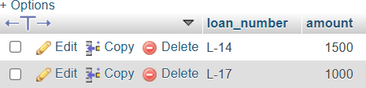

2. Find the account numbers and branch names of all accounts with

a balance between 300 and 800 in the account relation.

Code:

SELECT account_number, branch_name FROM account

WHERE balance BETWEEN 300 AND 800;

Explanation:

Here account _number is the column name and table name is account .it is selected the downtown branch account number from the account table where balance is between 300 and 400.

Output:

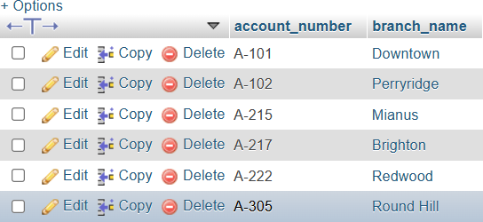

3. Find the names and account numbers of all customers from the

depositor relation who have an account at the Perryridge.

branch.

code:

SELECT depositor.customer_name, depositor.account_number, account.branch_name FROM depositor

JOIN account ON account.account_number = depositor.account_number WHERE account.branch_name 'Perryridge';

Explanation:

Here join operation execute between depositor and account table where branch name is Perryridge.

Output:

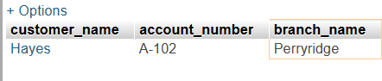

4. List the branch names where the total assets are higher than the average assets of all branches.

Code:

SELECT DISTINCT branch.branch_name,

branch.assets FROM branch

WHERE branch.assets > (SELECT AVG(branch.assets) FROM branch);

Explanation:

Here branch_name is the column name and table name is branch .it is selected the branch.assets is greater then from the AVG 9branch.assets).

Output:

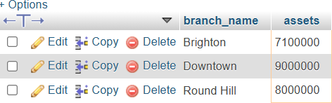

5. List the names of all customers who have both a loan and an account.

Code:

SELECT borrower.customer_name, loan.loan_number, account.account_number FROM borrower

JOIN loan ON loan.loan_number = borrower.loan_number JOIN account ON account.branch_name = loan.branch_name;

Explanation:

Here customer_name,account_number,loan_number is the column name and the join table execute between 3 tables which is borrower and loan and account .it is selected the customers who have both a loan and an account.

Output:

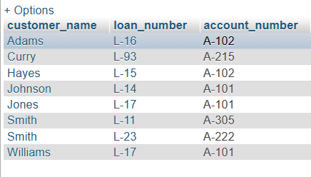

6. Find the names of customers who have a loan amount greater than the average loan amount of all loans.

Code:

SELECT borrower.customer_name FROM borrower

JOIN loan ON loan.loan_number = borrower.loan_number WHERE loan.amount > (SELECT AVG(loan.amount) FROM loan);

Explanation:

Here customer_name,loan_number is the column name and the join table execute between 2 tables which is borrower and loan .it is selected customers who have a loan amount greater than the average loan amount of all loans.

Output:

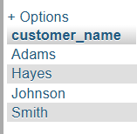

7. List all loan numbers and their amounts for loans that are greater than the maximum account balance in the Perryridge branch.

Code:

SELECT loan_number, branch_name, amount FROM loan

WHERE amount > (SELECT MAX(amount) FROM loan WHERE loan.branch_name = 'Perryridge');

Explanation:

Here branch_name,loan_number ,amount is the column name and the table name is loan .it is selected all loan numbers and their amounts for loans that are greater than the maximum account balance in the Perryridge branch.

Output:

